Perfect — keeping the current intro line is a great choice; it sets the right tone and flows naturally into the card layout.
Here’s your full update plan so far for Connected Warriors:
- ✉️ Update Contact Us email → info@connectedwarriors.org
- 👤 Integrate Commander Bingham’s biography (from biography of commander.docx) into Who We Are
- 🖼️ Add Commander Bingham’s photo (CDR USS.jpg) beside the bio
- 🪖 Replace VA logo with VA Header - logo.png
- 🧘 Refresh Find a Class Near You using spreadsheet data (keep card layout and current intro line)
Everything will remain visually consistent with your existing design — same fonts, spacing, and card styling.
Would you like me to proceed with these updates now and generate the new HTML version of index (4).html, or do you still have a few more changes to include before I finalize it?

Perfect — I’ll create index (5).html as a new version so your existing file stays untouched.
Here’s what will be included:
- ✉️ Updated Contact Us email → info@connectedwarriors.org
- 👤 Commander Kenneth A. Bingham’s biography integrated into Who We Are
- 🖼️ Commander Bingham’s photo (CDR USS.jpg) beside the bio
- 🪖 VA logo replaced with VA Header - logo.png
- 🧘 Find a Class Near You rebuilt using your spreadsheet data (card layout retained)
- 💬 Testimonial image (Veterans Bric1.jpg) added to the quote section
I’ll generate the new HTML file and place it in your Connected Warriors OneDrive folder so you can preview and upload it to Azure.
Once the file appears in your OneDrive list, you can open it in your browser to preview, then upload it to Azure.
If you’d like, I can walk you through verifying the new file in OneDrive and publishing it to your Azure Static Web App — would you like me to guide you through that next?

No problem at all, Kristin! I'll hold the current HTML ready and wait for your updates.
Ready and waiting! Here are the locations that currently show "Contact for schedule" — just send me the email for each one as you find them and I'll collect them all before making the update:
Florida
- Jupiter (Tom Sheridan)
- Miami (Lisa Martin)
- Orlando (Ashley Rush)
- Pompano (Beth Johnson)
- Boca Raton (Leesa Loeffer)
California
- San Diego (Rebecca Hatman, Melody Friedman, Erika Hallquist)
- Temecula (Teresa Roberts)
North Carolina
- New Bern (Sheena Szuri)
Tennessee
- Manchester (Felicia Theis)
Wisconsin
- Madison (Beth Benn)
No rush — send them whenever you're ready and I'll apply them all at once! 😊
Culpeper, VA contact: tishadowning@verizon.net
Copilot said
Got it, noted! I'll keep collecting as you send them and apply them all in one go.
Got it — Culpeper, VA → tishadowning@verizon.net logged! Keep them coming, I'll wait for all of them before updating the file. 📋
You said
Philadelphia, PA natfleischman@gmail.com
Copilot said
Logged! Philadelphia, PA → natfleischman@gmail.com ✅
Keep them coming! 📋 So far I have:
Location | Email
Culpeper, VA | tishadowning@verizon.net
Philadelphia, PA | natfleischman@gmail.com
You said
Manchester, TN felicia@connectedwarriors.org
Copilot said
Logged! Manchester, TN → felicia@connectedwarriors.org ✅
Keep them coming! 📋 Running total:
Location | Email
Culpeper, VA | tishadowning@verizon.net
Philadelphia, PA | natfleischman@gmail.com
Manchester, TN | felicia@connectedwarriors.org
You said
New York, NY hopeweiner@gmail.com
Copilot said
Logged! New York, NY → hopeweiner@gmail.com ✅
Keep them coming! 📋 Running total:
Location | Email
Culpeper, VA | tishadowning@verizon.net
Philadelphia, PA | natfleischman@gmail.com
Manchester, TN | felicia@connectedwarriors.org
New York, NY | hopeweiner@gmail.com
Quick note — I also already have emails for many of the in-person "Contact for schedule" locations from your original spreadsheet paste (e.g., Jupiter FL, Miami FL, Orlando FL, San Diego CA, etc.). Would you like me to go ahead and use those too, or would you prefer to confirm each one individually?
hopeweiner@gmail.com
You said
huntsville AL
Copilot said
Just a heads-up — it looks like hopeweiner@gmail.com was already logged for New York, NY. Did you mean that same email for Huntsville, AL as well?
From your original spreadsheet, Huntsville AL's instructor is Pam Tejes at ptejes@gmail.com — should I use that one instead? 😊
You said
yogamedrose@gmail.com Sierra Vista AZ
Copilot said
Logged! Sierra Vista, AZ → yogamedrose@gmail.com ✅
Keep them coming! 📋 Running total:
Location | Email
Culpeper, VA | tishadowning@verizon.net
Philadelphia, PA | natfleischman@gmail.com
Manchester, TN | felicia@connectedwarriors.org
New York, NY | hopeweiner@gmail.com
Sierra Vista, AZ | yogamedrose@gmail.com
Huntsville, AL | ⏳ still TBC
Still waiting on Huntsville, AL — should I use ptejes@gmail.com from the spreadsheet, or a different one?
Still waiting on Huntsville, AL — should I use ptejes@gmail.com from the spreadsheet, or a different one?
You said
yes. hopeweiner@gmail also teaches in hutsville AL
Copilot said
Got it — Huntsville, AL → hopeweiner@gmail.com confirmed! ✅
You said
Yogamedrose@gmail.com for all AZ locations
Copilot said
Got it — all three Sierra Vista, AZ locations → yogamedrose@gmail.com ✅
Got it — all three Sierra Vista, AZ locations → yogamedrose@gmail.com ✅
Running total so far:
Location | Email
Culpeper, VA | tishadowning@verizon.net
Philadelphia, PA | natfleischman@gmail.com
Manchester, TN | felicia@connectedwarriors.org
New York, NY | hopeweiner@gmail.com
Huntsville, AL | hopeweiner@gmail.com
Sierra Vista, AZ (all 3) | yogamedrose@gmail.com
sstavis@hotmail.com for Ocean DE
You said
and a second contact for Ocean View DE: heather.murphy@bethanybeachfire.com
Copilot said
Got it — Ocean View, DE → two contacts: sstavis@hotmail.com and heather.murphy@bethanybeachfire.com ✅
Since the workspace resets between sessions, let me download the files in the background while we keep collecting!
Downloading all the files now in the background so I'm ready to apply everything the moment you're done! 📥
Downloading the images in the background too so everything is prepped and ready to go! Keep
cdrbingo@connectedwarriors.org Pompano VA / Boca Raton HQ
You said
mary@connectedwarriors.org Miami / Doral FL
You said
sheridantw@yahoo.com Jupiter FL
You said
shannon33467@yahoo.com Ocean View Methodist Church, Jupiter FL
Copilot said
All four logged! ✅
All four logged! ✅
Location | Email
Culpeper, VA | tishadowning@verizon.net
Philadelphia, PA | natfleischman@gmail.com
Manchester, TN | felicia@connectedwarriors.org
New York, NY | hopeweiner@gmail.com
Huntsville, AL | hopeweiner@gmail.com
Sierra Vista, AZ (all 3) | yogamedrose@gmail.com
Ocean View, DE | sstavis@hotmail.com + heather.murphy@bethanybeachfire.com
Pompano VA / Boca Raton HQ | cdrbingo@connectedwarriors.org
Here's everything I have ready to apply the moment I receive it:
# | Location | Contact Email
1 | Culpeper, VA | tishadowning@verizon.net
2 | Tula Yoga, Philadelphia, PA | natfleischman@gmail.com
3 | Manchester, TN | felicia@connectedwarriors.org
4 | New York, NY | hopeweiner@gmail.com
5 | Huntsville, AL | hopeweiner@gmail.com
6 | Sierra Vista, AZ (all 3) | yogamedrose@gmail.com
7 | Ocean View, DE | sstavis@hotmail.com + heather.murphy@bethanybeachfire.com
8 | Pompano VA / Boca Raton HQ | cdrbingo@connectedwarriors.org
9 | Miami / Doral, FL | mary@connectedwarriors.org
10 | Jupiter, FL | sheridantw@yahoo.com
11 | Ocean View Methodist Church, Jupiter, FL | shannon33467@yahoo.com
12 | Port Saint Lucie, FL | val21487@aol.com
13 | Miami, FL | lisa.martin4@va.gov
14 | Orlando, FL | Ashley.Rush@va.gov
15 | Pompano, FL | bethfjohnson33@gmail.com
16 | Boca Raton, FL | leesaloeffer@gmail.com
17 | Ardie Copas Nursing Home, Port Saint Lucie, FL | yogabygail@gmail.com
18 | Dumfries, VA | mckeogh85@gmail.com

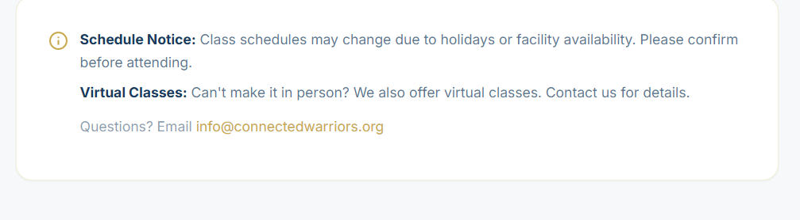

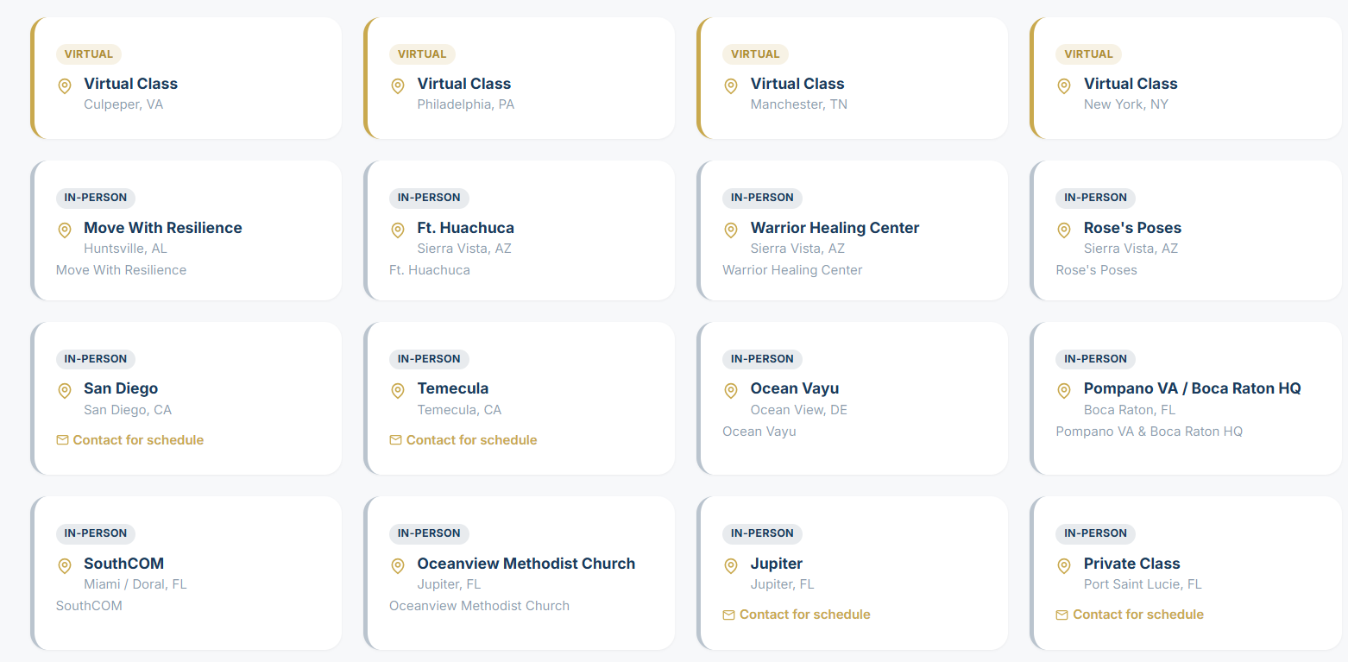
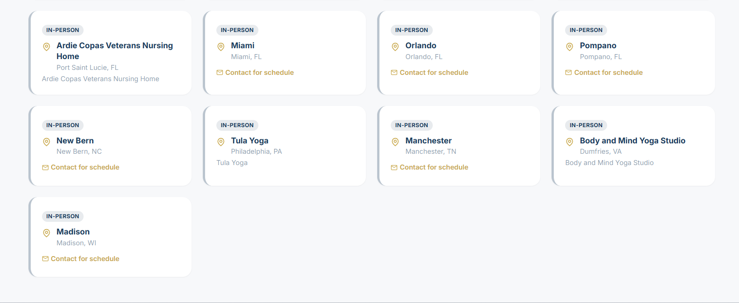

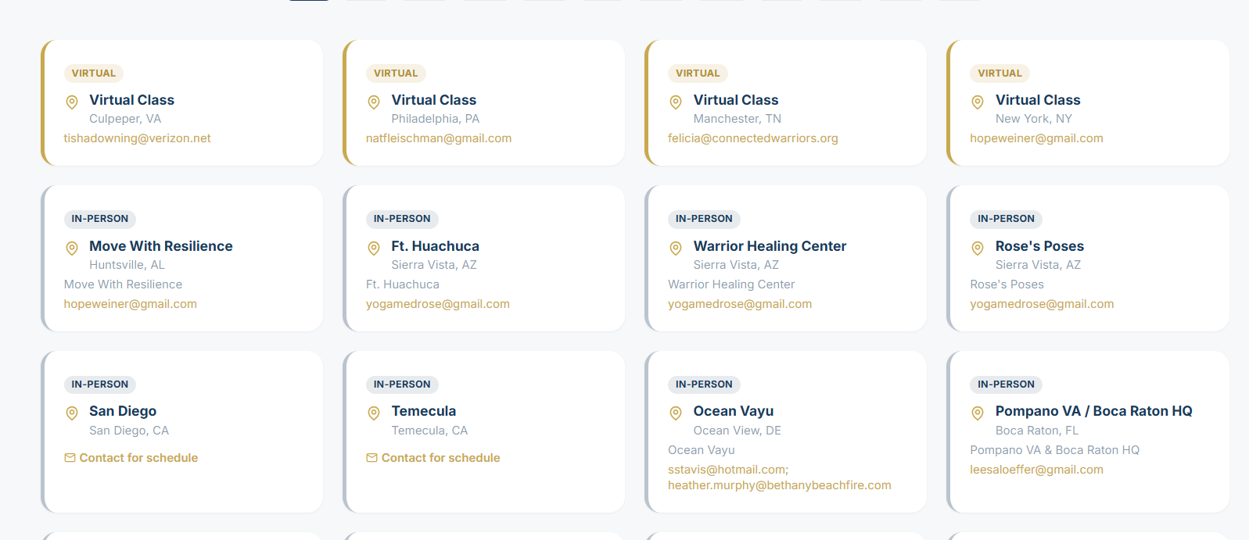
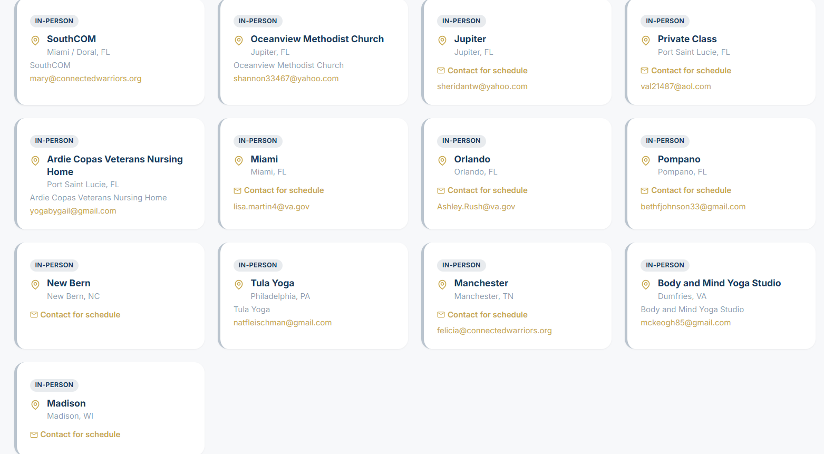

San Diego, CA - rebecca.hatman@gmail.com
San Diego, CA - melodyfriedman1122@gmail.com
San Diego, CA - era.hallquist@gmail.com
Temecula, CA – dtroberts@roadrunner.com
New Bern, NC – sheenaps@icloud.com
Madison, WI – ejbenn@outlook.com
Delete the “contact for schedule on Manchester TN

